RACHELA OLEWSKI [ZELMANOWICZ]
1921-1987
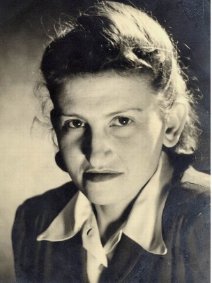

Rachela Zelmanowicz was born in October 8th, 1921 in Bendzin, Poland.
She was a thin and spoiled girl, and had very bad habits of eating [which later helped her survive in Auschwitz…].

In September 1^{st,} 1939, a month before her 18th birthday, the war broke.
Her mother died while they were in the Bendzin ghetto.
August 1st, 1943: her brother Dov was deported to Auschwitz.
August 3rd, 1943: Rachela and her father were deported to Auschwitz.
Her father Leibek was sent to the gas chambers, on his 53rd birthday...
Rachela got a tattooed number on her left arm – 52816, and was later pushed by her brother's girlfriend to join the women's orchestra of Auschwitz, A-Lager, Block 15. Rachela was 21 years old. Since then and for 15 months she was playing the mandolin to survive. [The conductor of the women's orchestra of Auschwitz was the famous Alma Rose’, the daughter of Gustav Mahler's sister Justine and of Arnold Rosé. Rosé had been the conductor of a women's orchestra in her hometown of Vienna.]
On October 7th, 1944, two days after he became 27, Rachela’s brother Dov was killed while taking part in the Sonder-Kommando's revolt.

November 2nd, 1944: The Jewish girls of the women's orchestra were deported by train to Bergen-Belsen.

April 15th, 1945: The British army liberates Bergen-Belsen.

Rachela and some of her friends started to walk to… Eretz-Israel. They reached as far as 20 km, to Celle. There, at the office of the Celle Jewish Committee, they met their future husbands.

January 15th, 1946: Rachela [who was then 24 years old] married Rafael Olewski [31], the first chairman of the Jewish community of Celle after 1945, and a prominent figure in the Jewish Central Committee of Bergen-Belsen. The wedding took place at the reconstructed Celle synagogue, and the Rabbi who married them was Rafael's brother, the famous Celler Rabbi, Rabbi Israel-Moshe Olewski.

March 15th, 1947: Rachela gave birth to her daughter Jochi [Jochevet-Rivka], at the Glyn-Hughes hospital in Bergen-Belsen DP camp.

April 3rd, 1949: Rafael, Rachela and Jochi made Aliya to Israel.

December 24th, 1950: Rachela gave birth to her son [Yehuda] Arie.

She was a loyal aid to her husband Rafael, who was the Chairman of the Bergen-Belsen survivors' Organization [She'erit Hapleta] in Israel, and Vice-President of the World Federation of Bergen-Belsen survivors. He died in November 1981.

April 1985: Rachela traveled with Jochi and Arie to Germany and Poland, within the context of celebrating 40 years of liberation from Bergen-Belsen.

She arrived to Auschwitz and tried in vein to find her Block and her brother's letters to her, which she had hid near the block.

She also went to Bendzin and visited her home in Malachowskiego st. 10.

On August 17, 1987, at the age of 65, Rachela died of cancer, in which she struggled for a long time, stubbornly and respectfully, without bothering anyone.

Rachela gave oral testimony to a Yad Vashem researcher in 1984. A copy of the transcript was sent to her, and was found near in her bed when she died. In 2006, the Director of Archives at the Auschwitz-Birkenau Museum sent her children an astonishing record - greetings from Hell: Rachela's work index card as documented by the SS in Auschwitz-Birkenau.

Her testimony in Hebrew and in English ("Crying is forbidden here!") was published privately, and have been printed in three editions so far. ISBN 978-965-91217-1-7

At the end of 2018 her story was published in a book in German.

